JUMP ROPE FOR HEART 2015-2016

**Dear Parents:**

During PE classes, November 20-24**,** our school will be participating in the

American Heart Association’s **Jump Rope for Heart** event!

* With the educational programs from the American Heart Association, our students learn how the heart works, how exercise affects their hearts and how to stay **FIT FOR LIFE**!
* Funds raised support the AHA’s research and education initiatives that save lives in our community. Heart disease & stroke are the No. 1 & No. 5 killers of all Americans and more people die of heart disease than all other forms of cancer combined. 1 in 3 are affected by heart disease!

**DEADLINE**: Donations are due back in your child’s envelope on **November 20th**. Please make checks payable to ***AMERICAN HEART ASSOCIATION*. PLEASE CONVERT CASH INTO A CHECK.** You can even check with your place of employment to see if they offer a matching gift. For the safety of our children, we ask that your child NOT go door-to-door or ask strangers for donations. Ask friends & fanuly or go online instead!

***Who let the DOGS out? Your child has the opportunity to earn six*** of our exclusive

American Heart Association PUPPY DOG COLLECTIBLES!



See the back of your child’s Jump Rope for Heart Envelope for the **first *LifeSaver DOG coupon*** – *this needs turned in to the PE teacher once your child raises* ***$5*** *to instantly receive the first exclusive SUPER PUP and Lanyard!*



* Once students receive their **first online donation** of ANY amount, print their donation report and send it to school for them to instantly receive their 2nd Lifesaver DOG (The NINJA STAR DOG)
* Once students receive **$85 in online donations**, print their donation report and send it to school for them to instantly receive their 3rd Lifesaver DOG! (Glow in the Dark Alien Dog)
* Once students earn **$100 total**, they earn a Skyzone Pass ( Indoor Trampoline Park) and earn ALL 6 PUPPY DOG COLLECTIBLES!
* Top Fundraiser will receive a Medal and Letter from the American Heart Association

All other DOGS earned will come with the rest of the prizes after the event! ***See back of this letter for online fundraising instructions – it’s fun, safe, easy, and a great way to raise lifesaving researching dollars!***

Sincerely,

***Mr. Conklin***

**Register Online for Jump Rope for Heart, Send Emails and Collect Donations!**

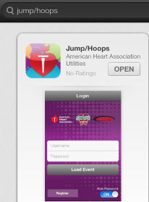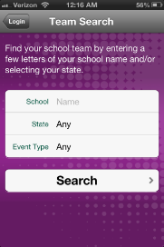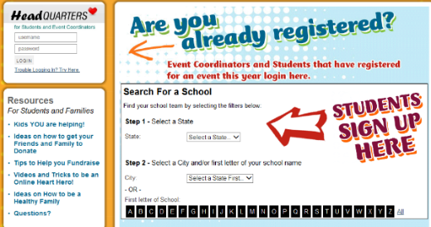

Don’t Have a Computer?

No Big deal! Download our FREE Jump/Hoops Mobile App and register your child today on your mobile device! It’s safe, easy & convenient! For Apple & Android users – search for “Jump/Hoops” under the App Store.

**Step 6:** A **Share With Your Friends** screen will pop up. Enter a message that you would like to share via social media and click on the program/s that you would like to use. When done, click the **Publish** button. (Click the “X” in the upper right hand corner of the pop up box to skip this step.)

*\*You’ll see a confirmation screen and a button you can click to enter your Headquarters and set up your web page!* **Congratulations! You have registered for Jump Rope For Heart online!**

**Step 7**: Email your family and friends using the email tab in your Headquarters. Ask for their support. When you receive your first online donation you will receive NINJA STAR DOG and when you reach $85 online you will receive the GLOW IN THE DARK ALIEN DOG.

**Step 4:** Create your own **Username and Password** and answer a security question. Click Continue. *\*\*Be sure your Username and Password are easy to remember. Write them here so you don’t forget:*

*My Username: _________________ My password:_________________*

**Step 5:** Fill out the registration form**.** On the bottom of the form there is an Online Waiver. Review the waiver with your parents to click the box to accept it. Once you are done, click the **Continue** button.

Questions? Call 800-309-3466

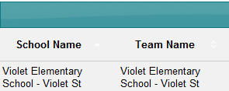

**Step 3:** When you find your school, click the **Join Team** hyperlink.

**Step 2:** In the **Search For a School** form, select your **school state** and **city**. A list of school names will open.

**Step 1:** Log in to your Headquarters web page by visiting www.heart.org/jump **and click on** the words that say ‘**Register Now!’**